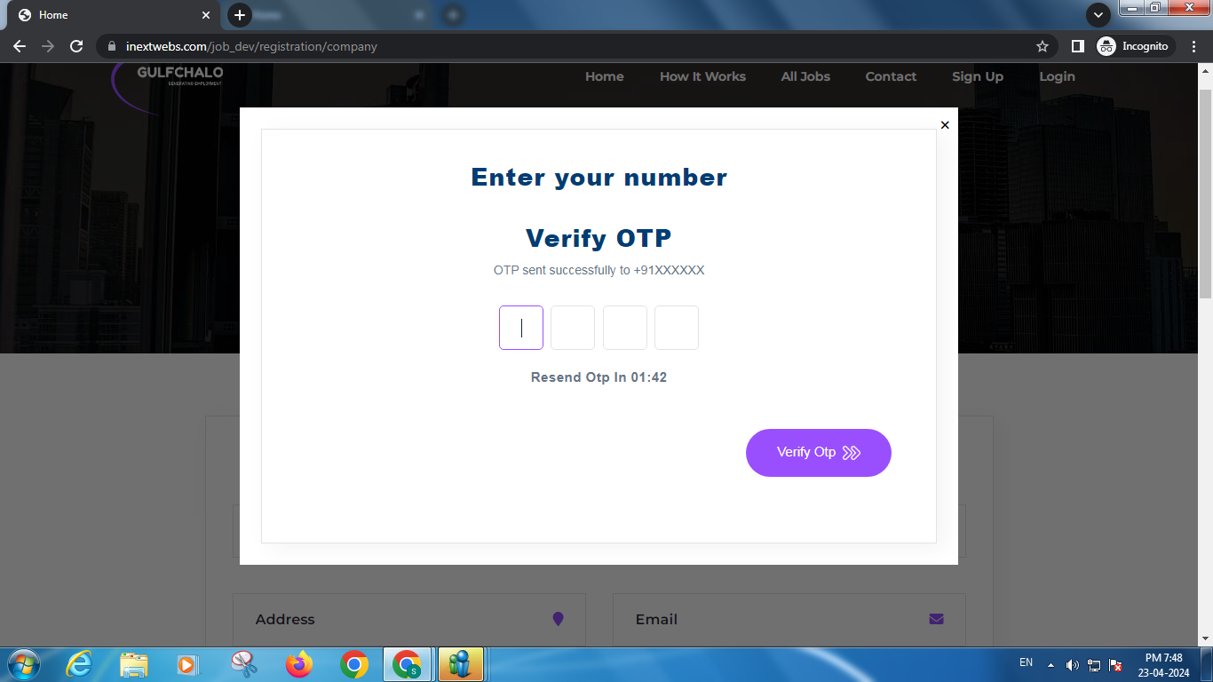

After selecting Email OTP it is showing otp sent to a number

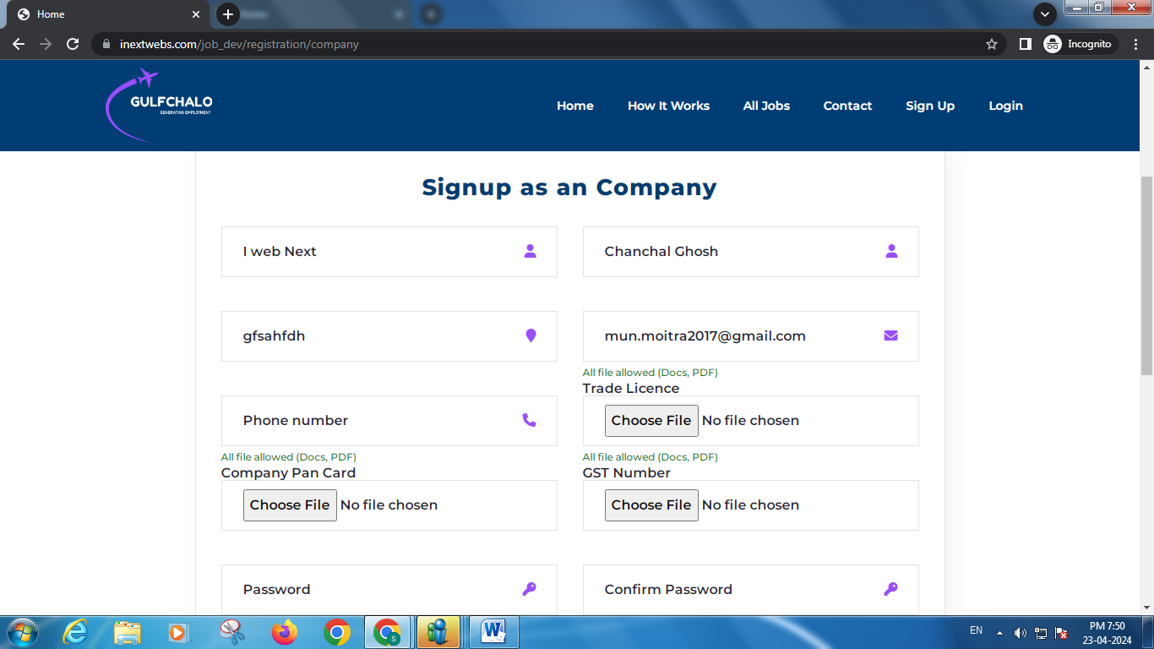

Unable to put phone number after registering by email, and the registered email is not constant in the form it can be changed

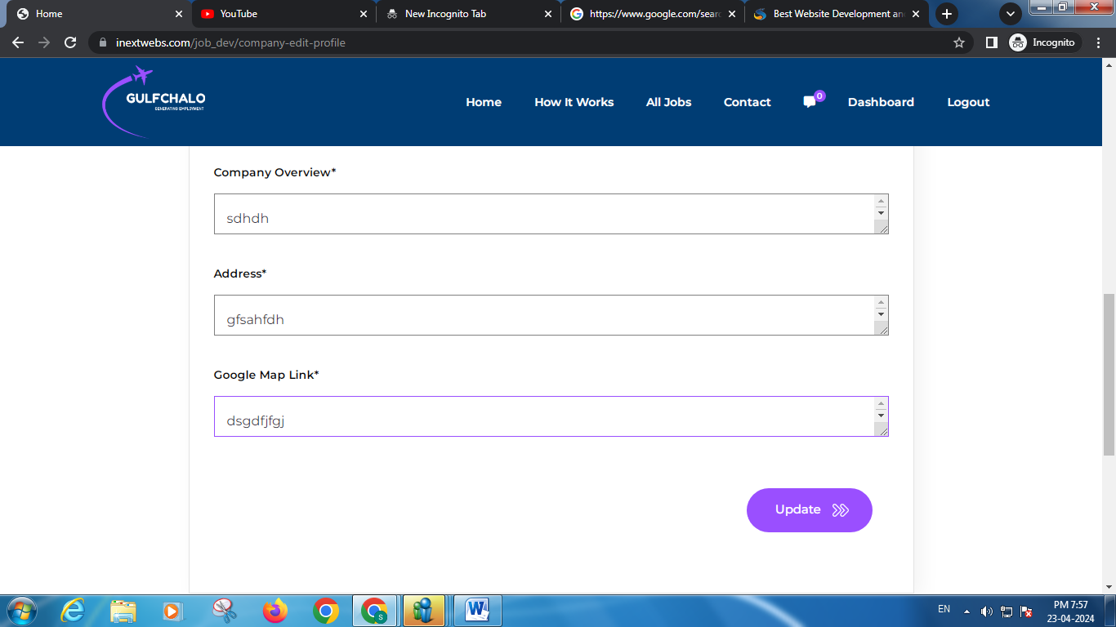

Put validation for google map link

After updating the profile redirect it to the company dashboard

In job post page validation is showing one by one as in one is getting fixed and the other one is showing

Put validation for all the sections as in post a job page

Check the order of salary and experience for max and min

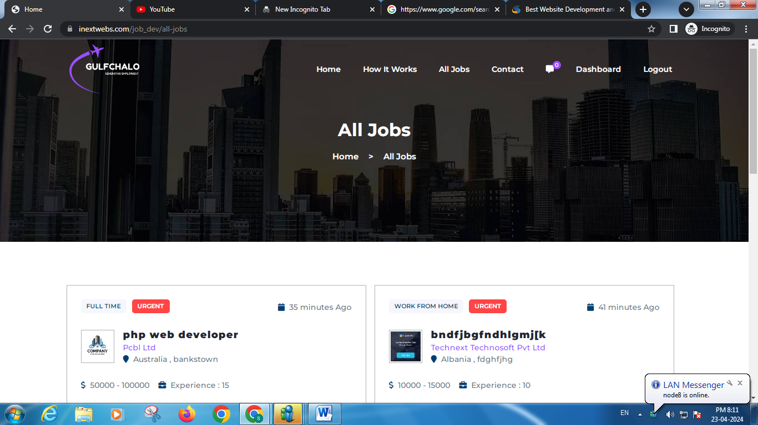

For all job section arrange the job from oldest to newest

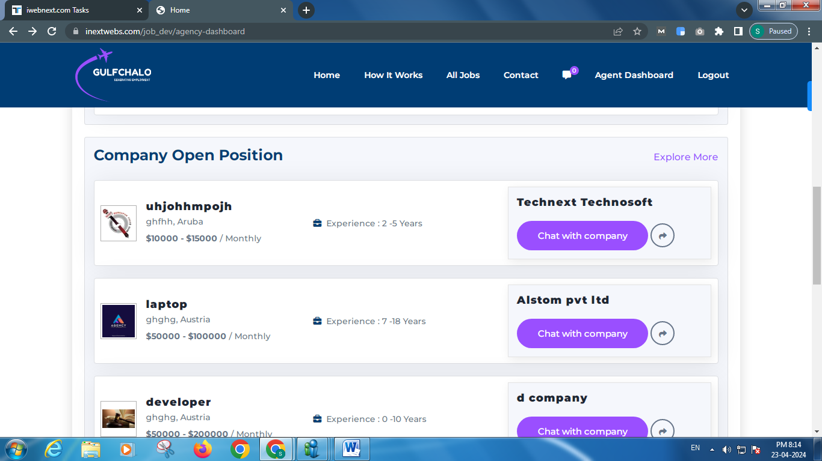

Change the order of the job for agency portal

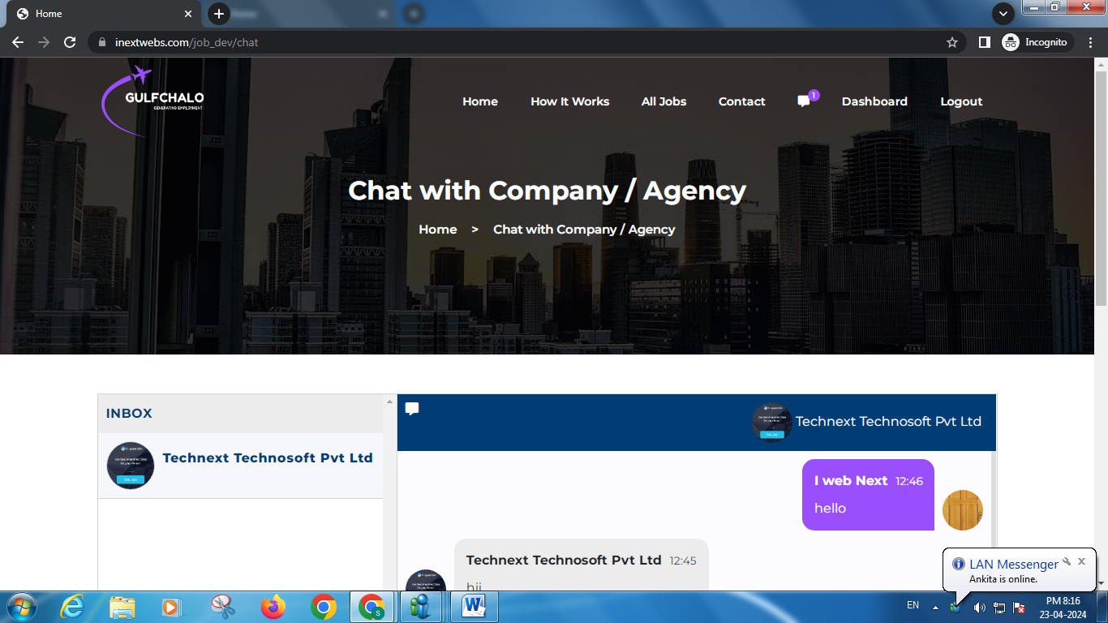

For company the header will be chat with agency

For agency the header will be chat with company/user

Order of the text will be newest to oldest

Order of the chat will be oldest to newest

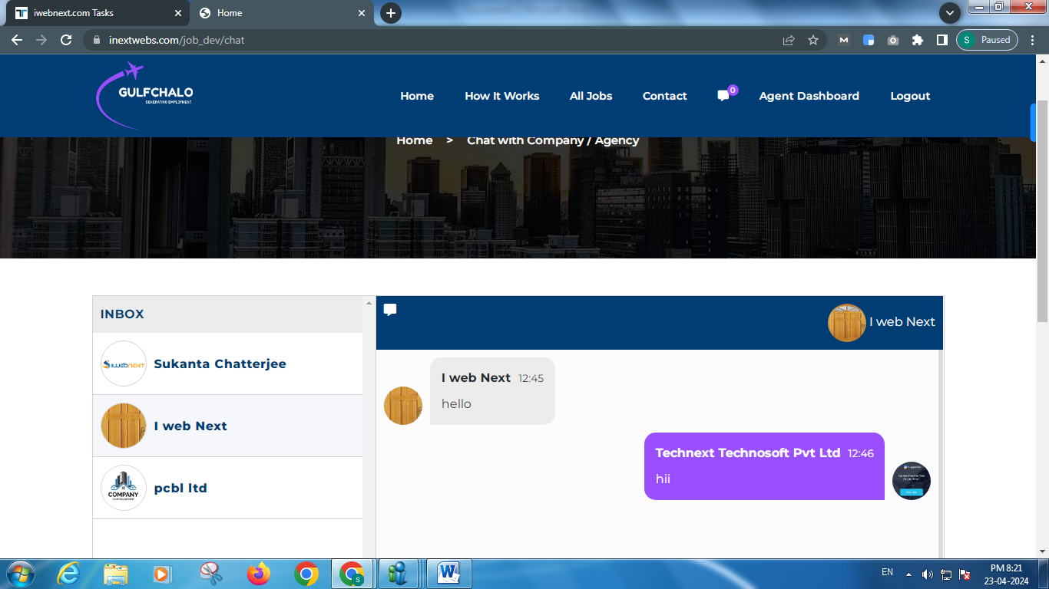

Rectification on time is needed